Project Design Phase-II Technology Stack (Architecture & Stack)

|  |  |
| --- | --- |
| Date | 19 September 2022 |
| Team ID | PNT2022TMID06453 |

**Technical Architecture: Real-Time River Water Quality Monitoring and Control System**

The Deliverable shall include the architectural diagram as below and the information as per the table1 & table 2

Example: The IoT - enabled Water Quality Monitoring (WQM) system enables real-time monitoring of freshwater resources

TECHNICAL ARCHITECTURE

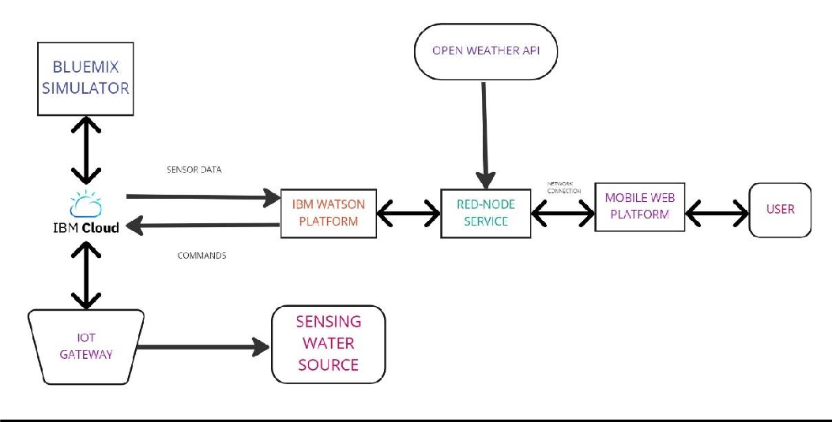

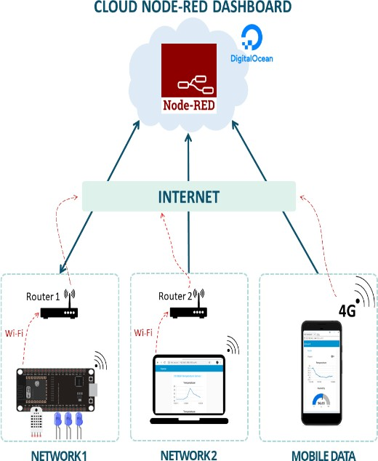**INDUSTRY 2.0** TECHNICAL ARCHITECTURE



**WIFI/INTERNET**

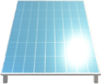**IBM CLOUD IOT WATSON PLATFORM**

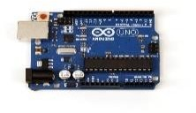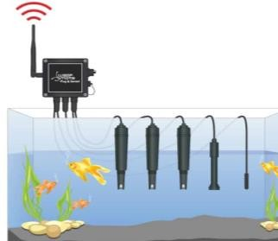

**SOLAR POWERED**

**MCU**



**REMOTE ACCESS**

**PYTHON RANDOM DATA**

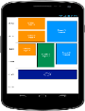

**FLASH SMS**

**SENSING WATER QUALITY**

Table-1 : Components & Technologies:

|  |  |  |  |
| --- | --- | --- | --- |
| S.No | Component | Description | Technology |
| 1. | User Interface | How user interacts with application | HTML, CSS, Node-Red ,Cloud,etc |
| 2. | Application Logic-1 | Logic for a process in the application | JAVA/PYTHON |
| 3. | Application Logic-2 | Logic for a process in the application | IBM WATSON STT services |

|  |  |  |  |
| --- | --- | --- | --- |
| 4. | Application Logic-3 | Logic for a process in the application | IBM WATSON Assistant |
| 5. | Database | Data Type, Configurations etc | MySQL, Postgres SQL |
| 6. | Cloud Database | Database Service on Cloud | IBM DB2, IBM Cloudant etc |
| 7. | File Storage | File storage requirements | IBM Block Storage or Other Storage Service or Local File system |
| 8. | External API-1 | Purpose of External API used in the application | IBM Weather API, etc |
| 9. | External API-2 | Purpose of External API used in the application | Aadhar API, etc |
| 10. | Machine Learning Model | Purpose of External API used in the application | Object Recognition Model, etc.. |
| 11. | Infrastructure (Server  / Cloud) | Application Deployment on Local System / Cloud Local Server Configuration: Cloud Server Configuration: | Local, Cloud Foundry, Kubernetes, etc. |

Table-2: Application Characteristics:

|  |  |  |  |
| --- | --- | --- | --- |
| S.No | Characteristics | Description | Technology |
| 1. | Open-Source Frameworks | List the open-source frameworks used | Technology of OpenSource framework |

|  |  |  |  |
| --- | --- | --- | --- |
| 2. | Security Implementations | List all the security / access controls implemented, use of firewalls etc | e.g. SHA-256, Encryptions, IAM Controls, OWASP etc. |
| 3. | Scalable Architecture | Justify the scalability of architecture (3 – tier, Micro- services) | Technology used |
| 4. | Availability | Justify the availability of application | Technology used |
| 5. | Performance | Design consideration for the performance of the application | Technology used |